# **Assignment**

1. Attach one EFS to two instances:

Step -1: Open AWS and search for EC2 and we can see security groups in security and network. Open security groups.

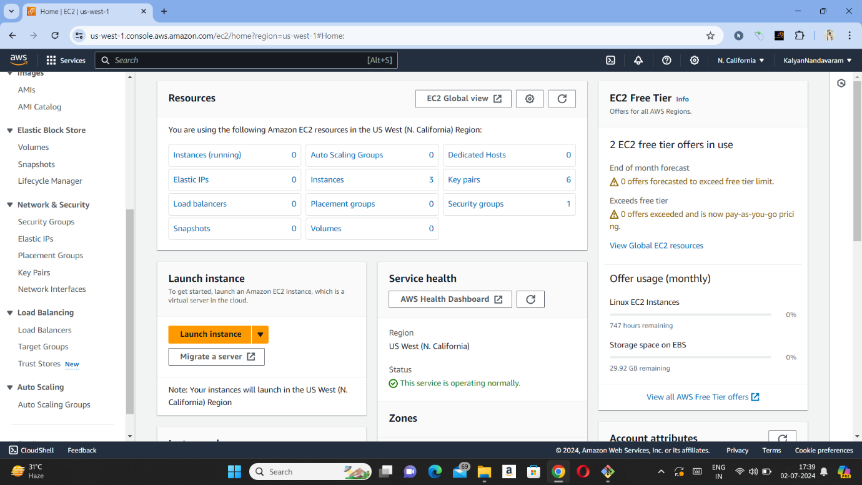

Step -2: After opening security groups, now create security group.

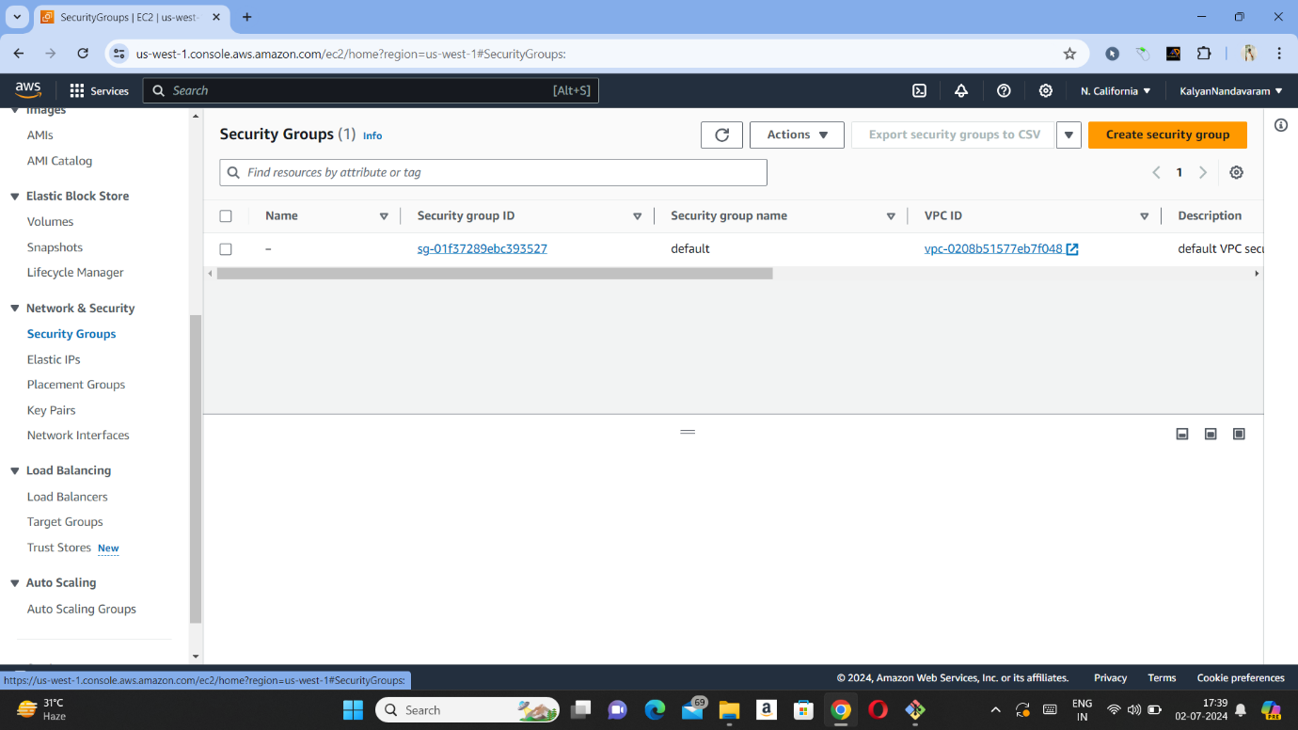

Step -3 : Now give security group name and description as allow.

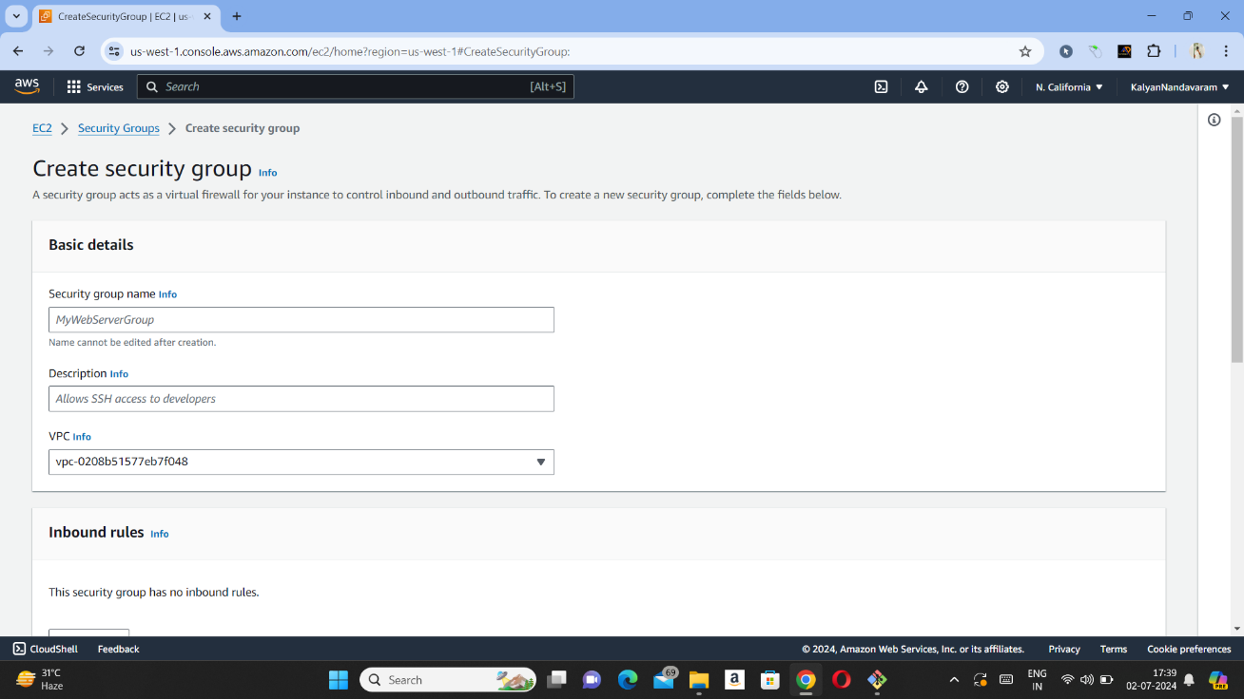

Step -4 : Now add inbound rules. In type we should select SSH and in source we need to select 0.0.0.0/0.

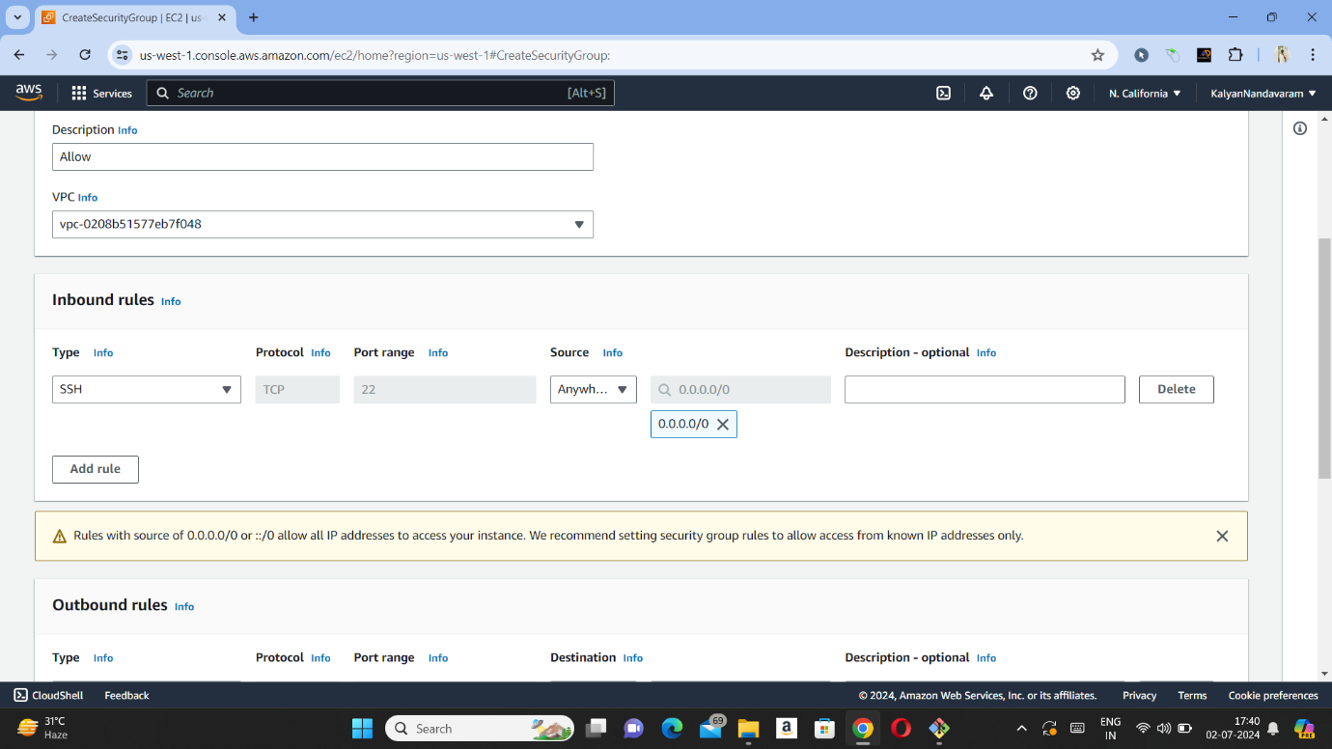

Step -5 : Now press create security group.

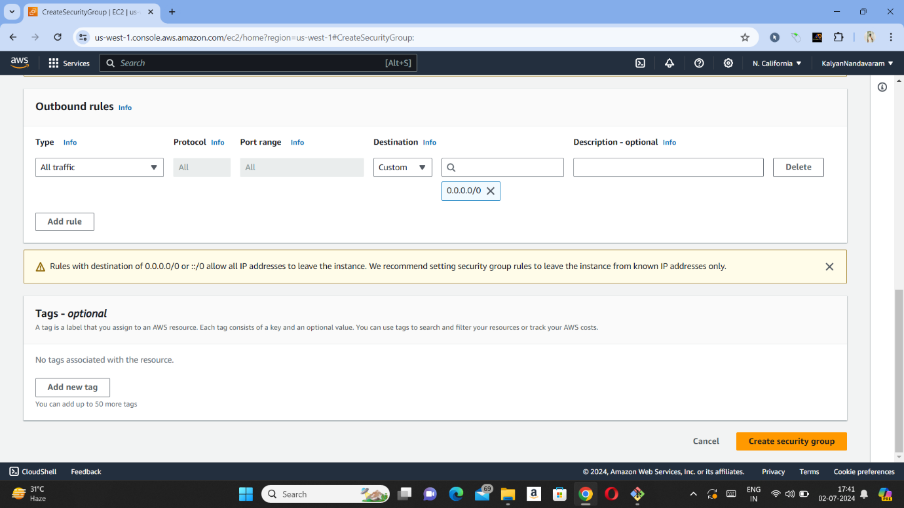

Step -6: Now search for EFS and press on EFS to open it and after opening EFS, press on create file system.

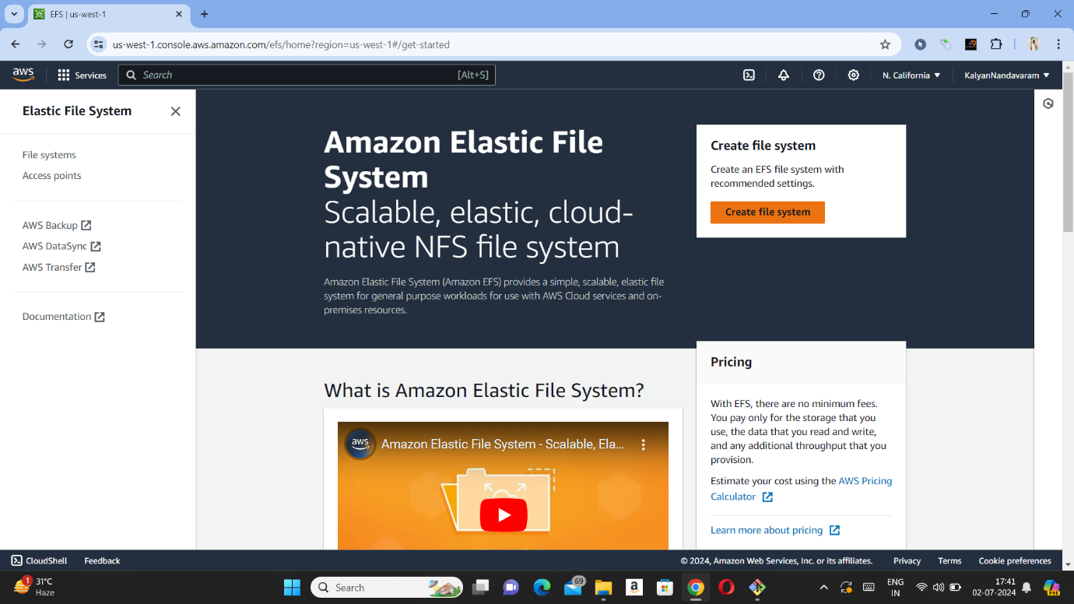

Step -7 : Now we need to give name and press customize to add mount targets.

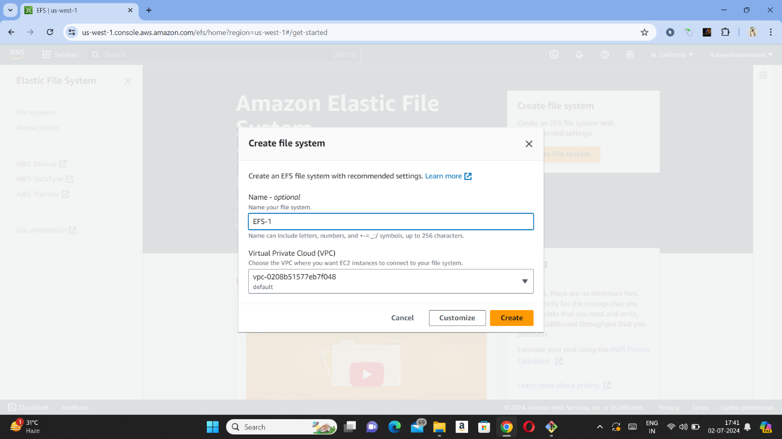

Step -8 : After pressing customize we need to press next and in mount targets we need to remove default security groups and add security groups which we have created and press next and press create.

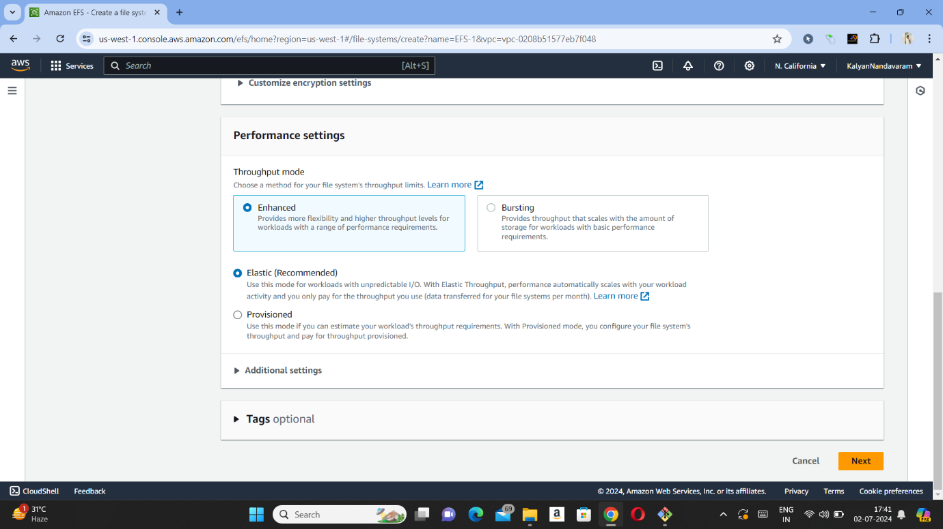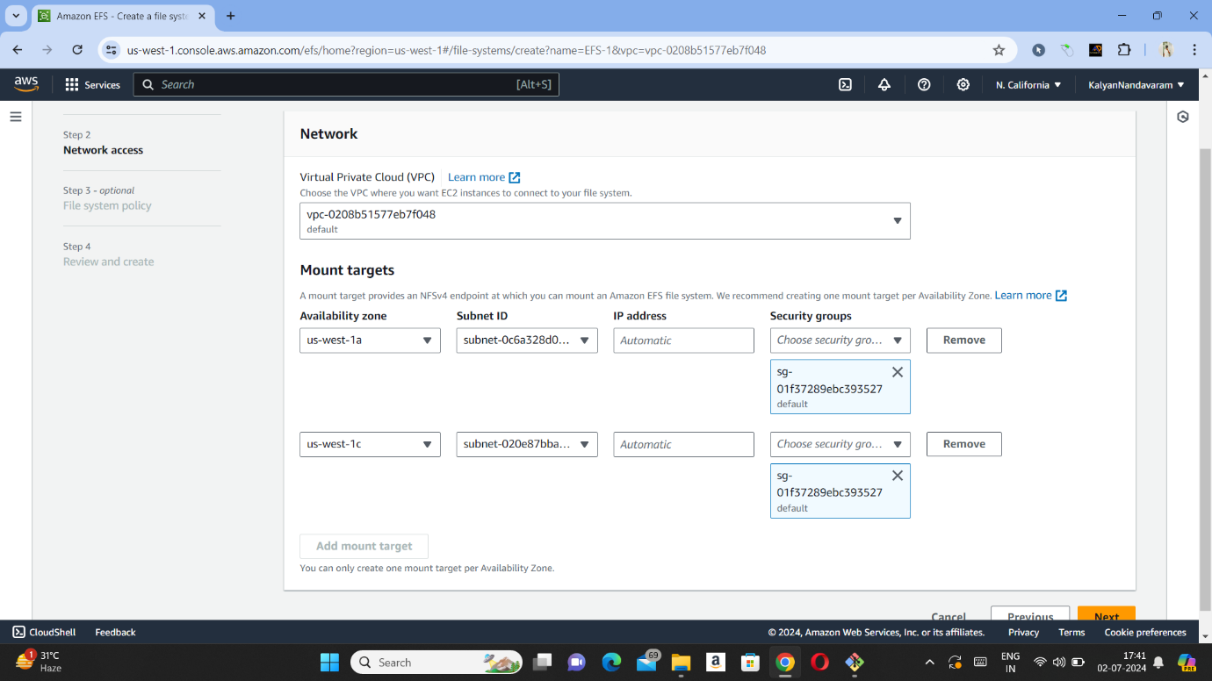

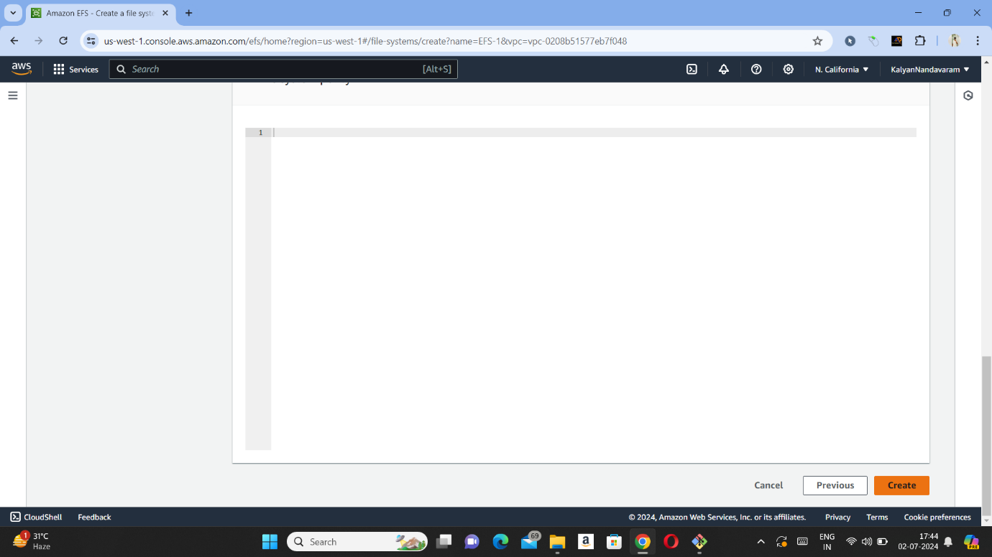

Step -9 : Now we need to search ec2 and press on instances (running) and need to launch two instances by pressing launch instance on top right and check whether files are sharing or not.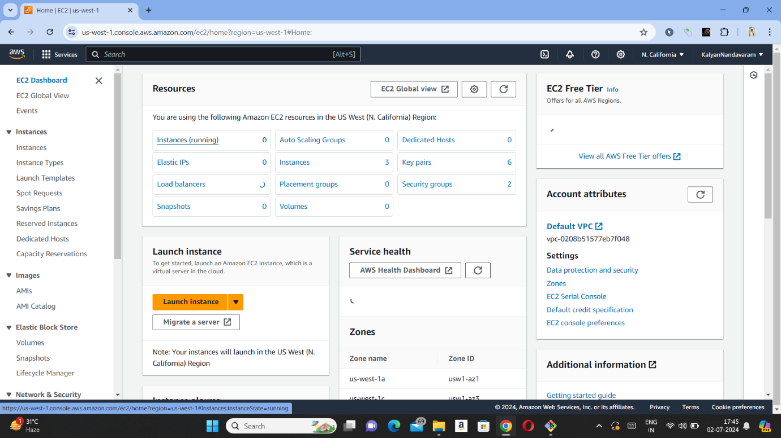

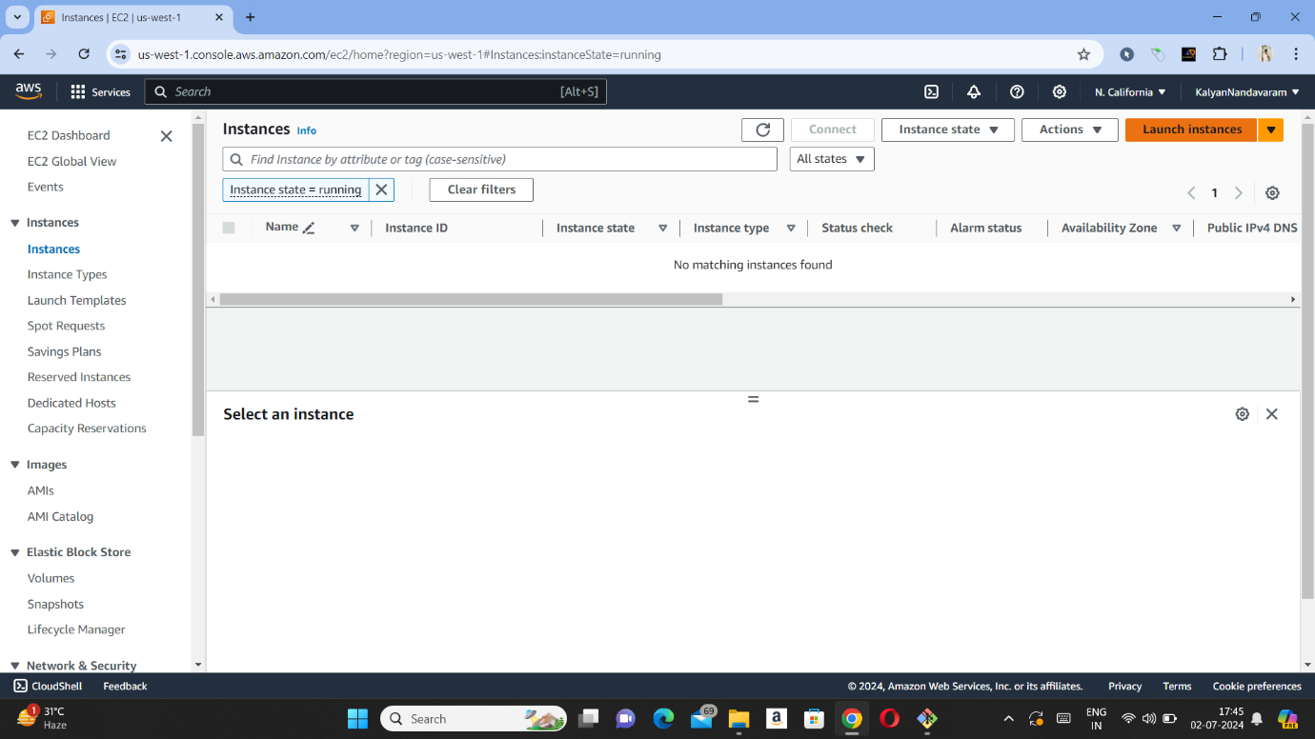

Step – 10 : Now we need to give name of the instance and need to create a new key pair.

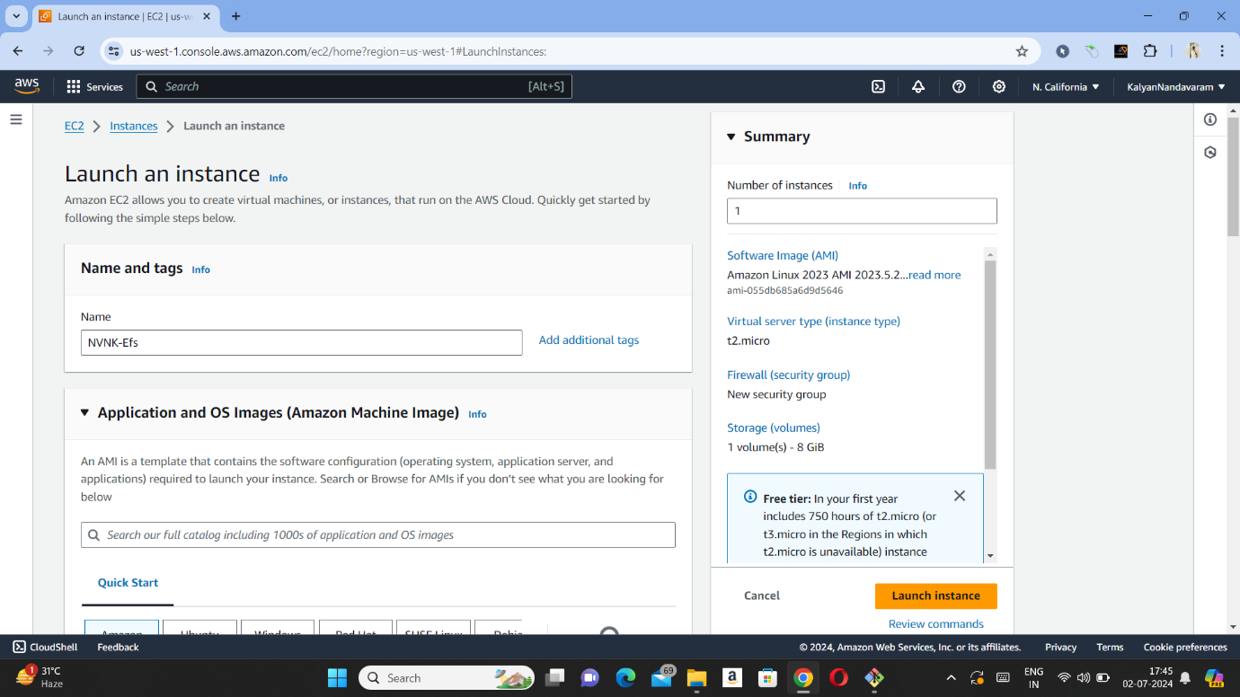

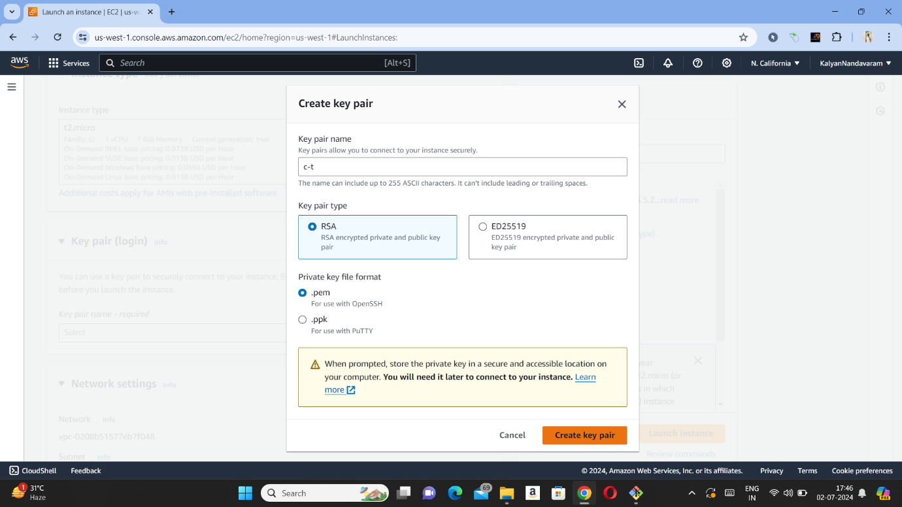

Step – 11 : Now we need to press edit in network settings and select subnet (we need to select different subnets for two instances). And select existing security group which we have created in step 2 and need to add file system which we have created in step 6 and press launch instance.

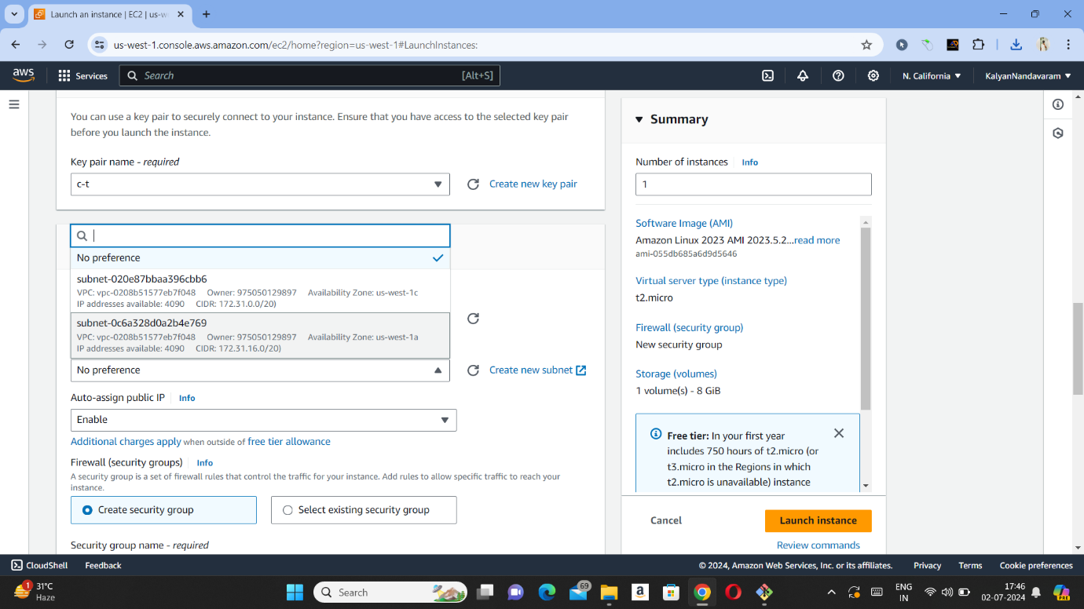

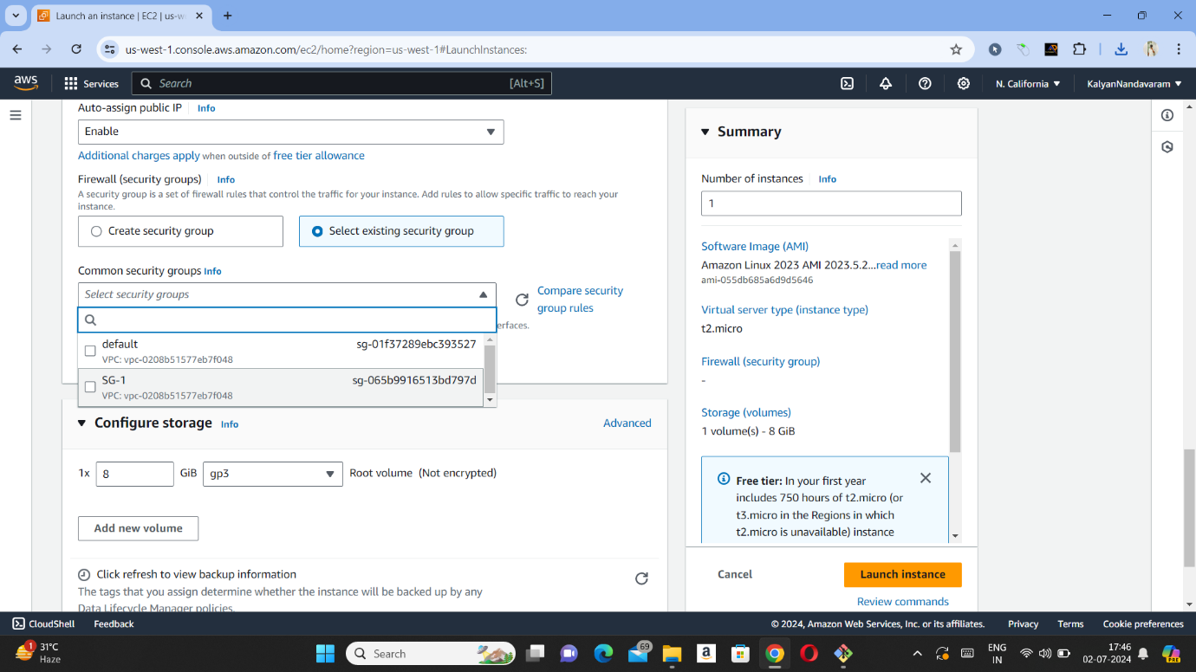

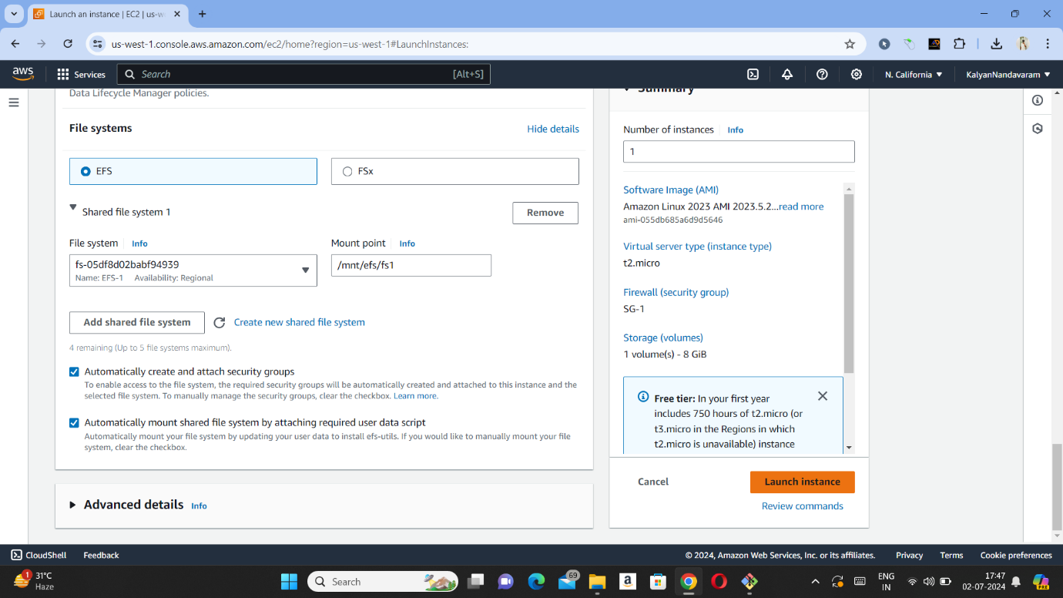

Step -12 : Now launch another instance same as above steps but with different available region.

Step – 13 : Now open downloads and cut .pem file and paste it on desktop.

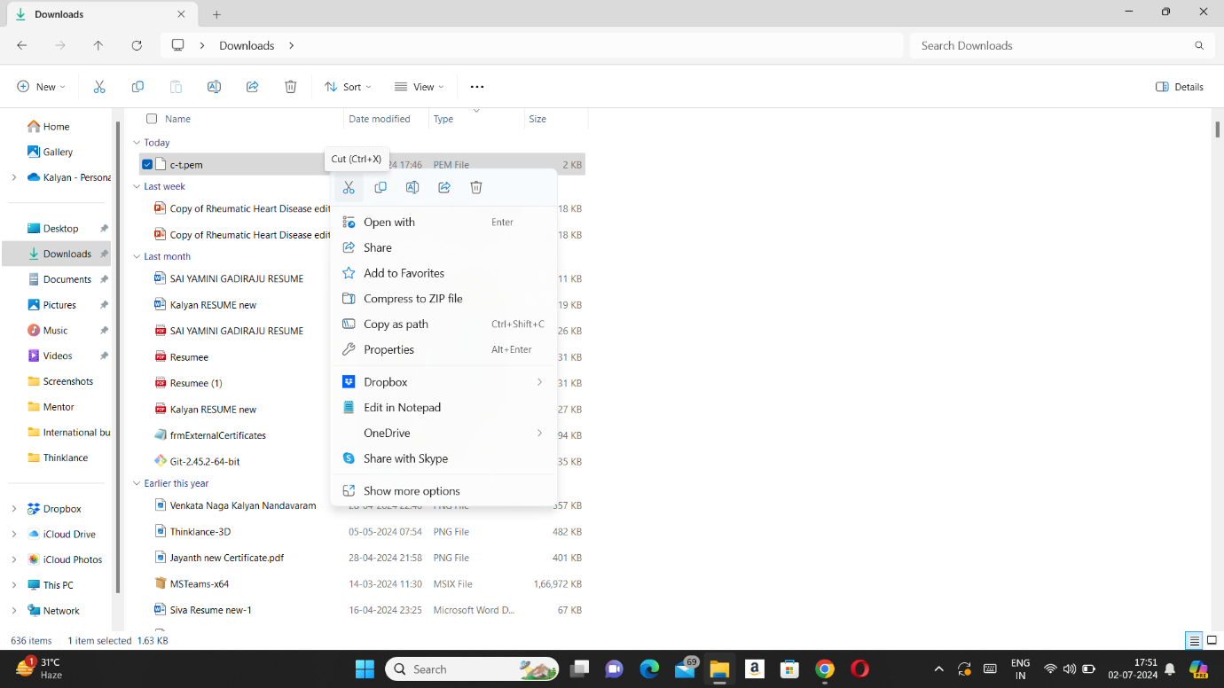

Step – 14 : Now open 1st instance and press connect and copy SSH link.

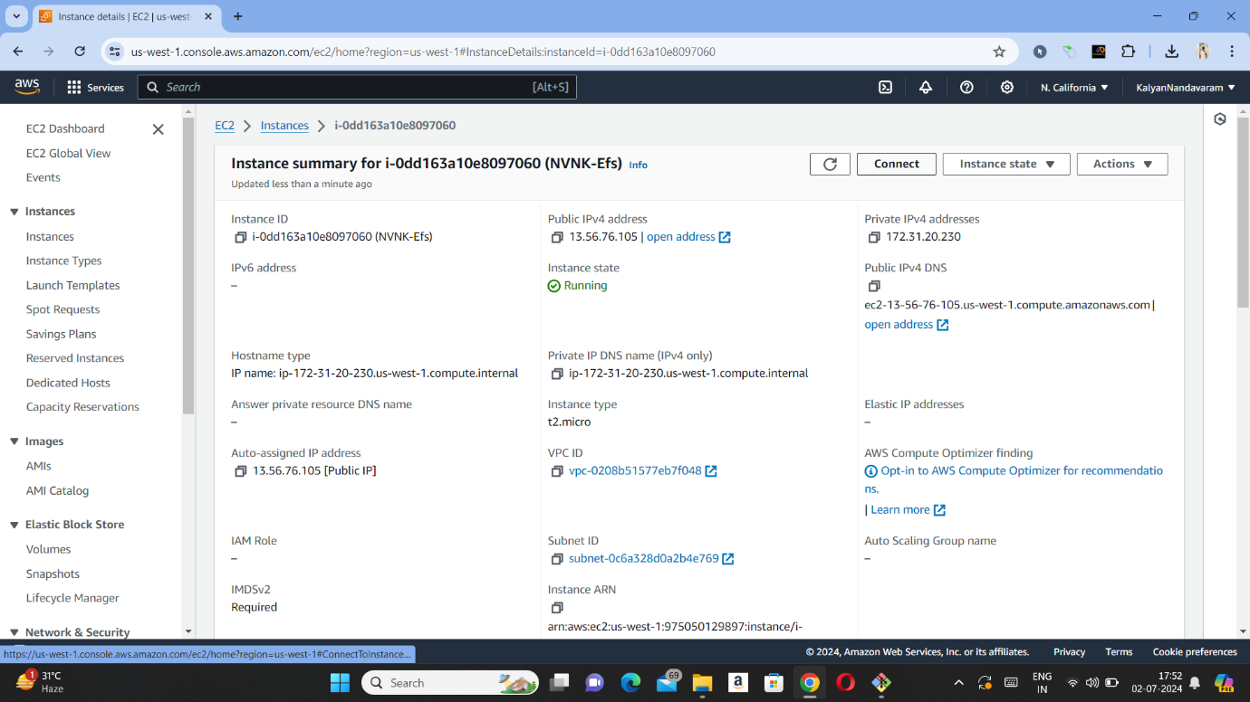

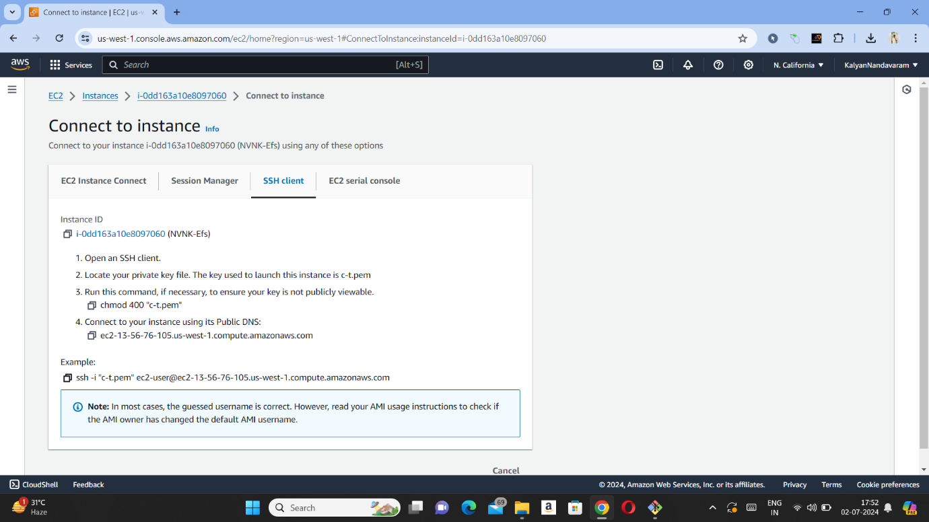

Step – 15 : Now open Git bash and paste SSH link in it and type sudo -i to become root user.

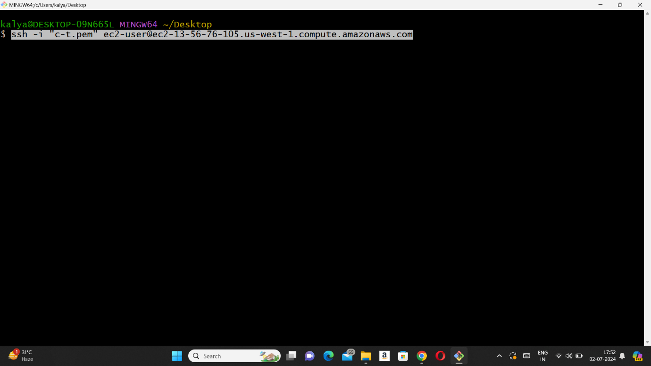

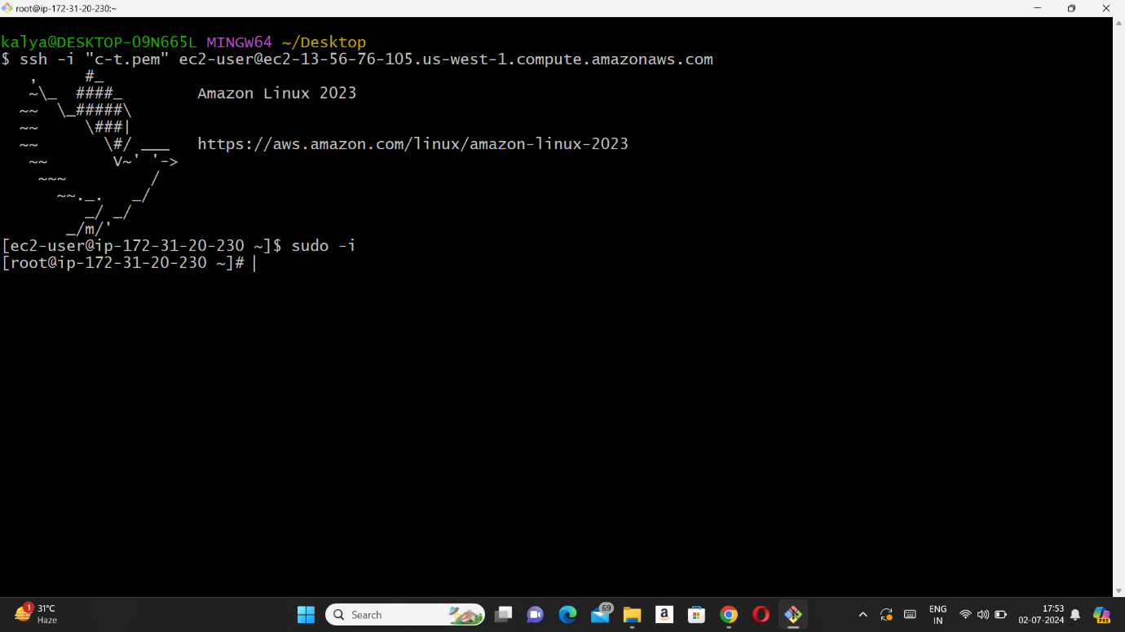

Step – 16 : Now we need to create file and we need to check whether file is sharing or not. We need to go fs1 directory and need to create a file as shown in below picture.

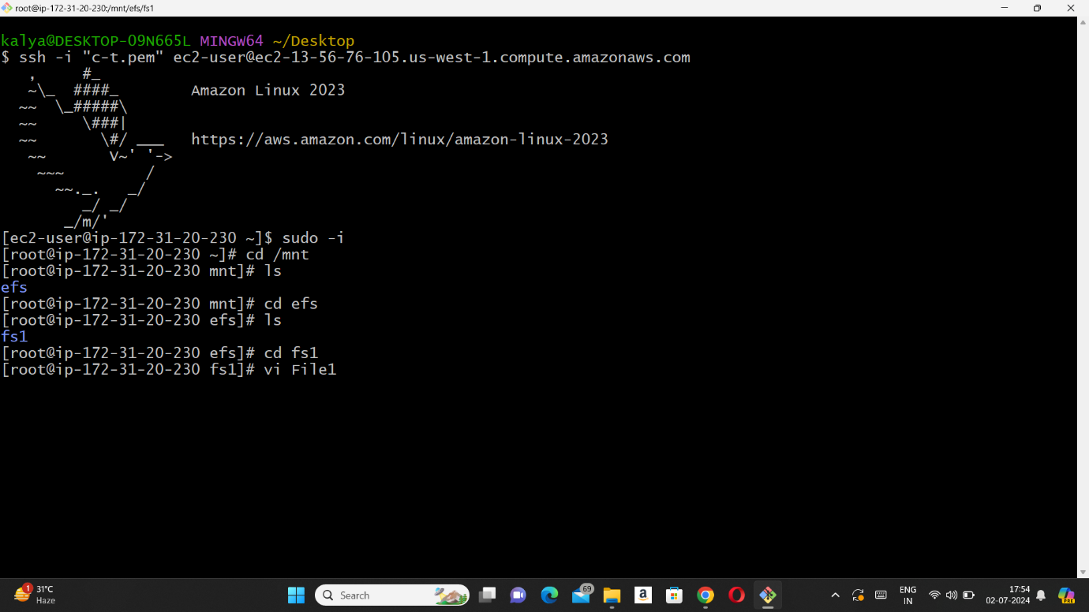

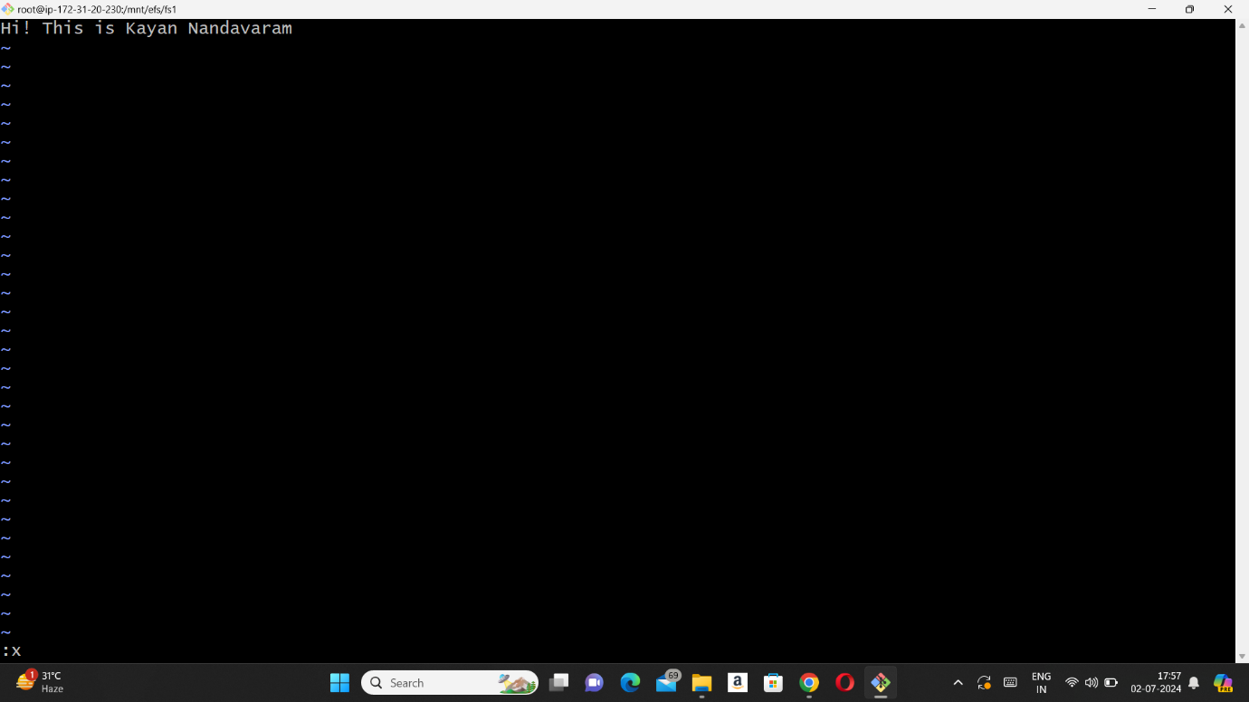

Step – 17 : Now we need to open another instance and need to connect it same as above steps and need to create a file and after creating we need to enter a command ‘ls’ (list) to check whether it is sharing or not.

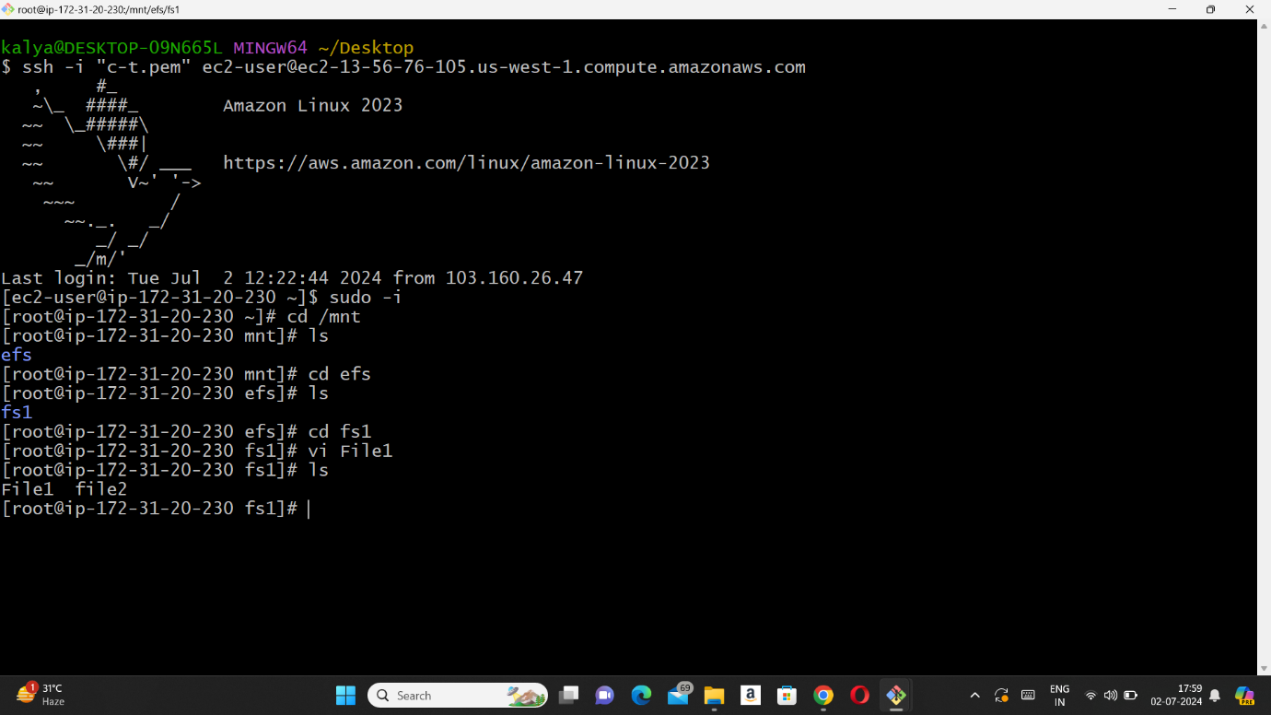

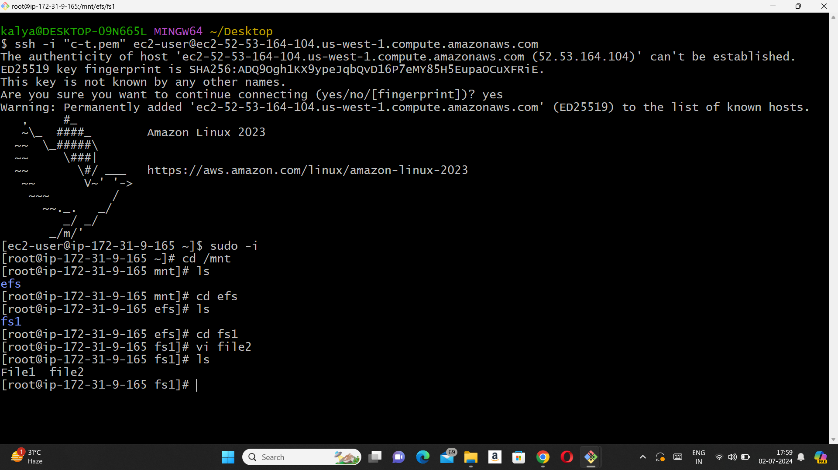

1. Attach EBS to an instance :

Step – 1 : Open AWS and search for EC2 and press instances (running).

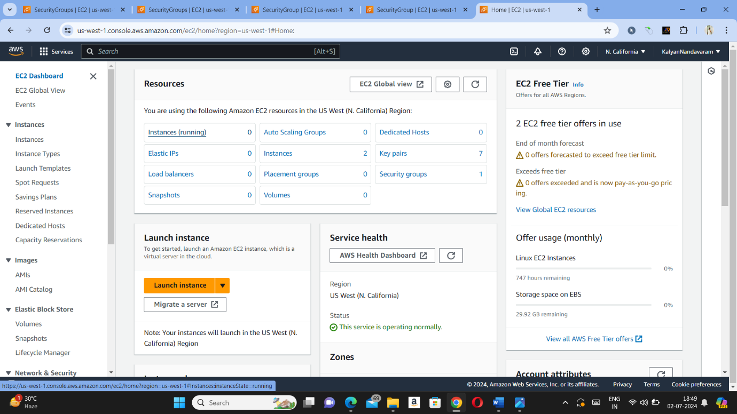

Step – 2 : Now we need to launch instance by pressing ‘launch instance’ on top right as shown in below picture.

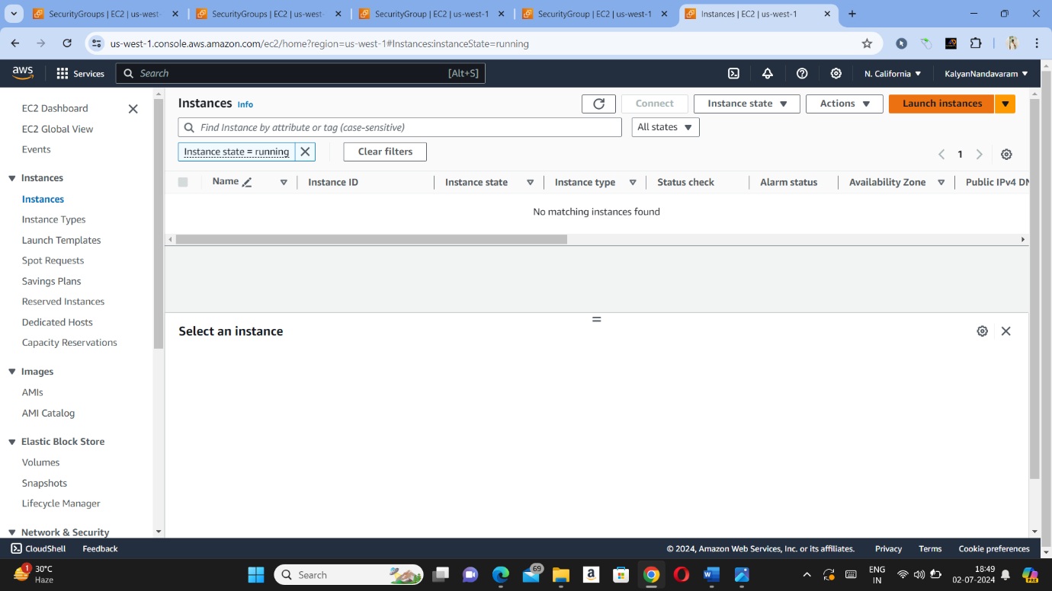

Step – 3 : Now we need to give name of the instance (I gave as EBS-1).

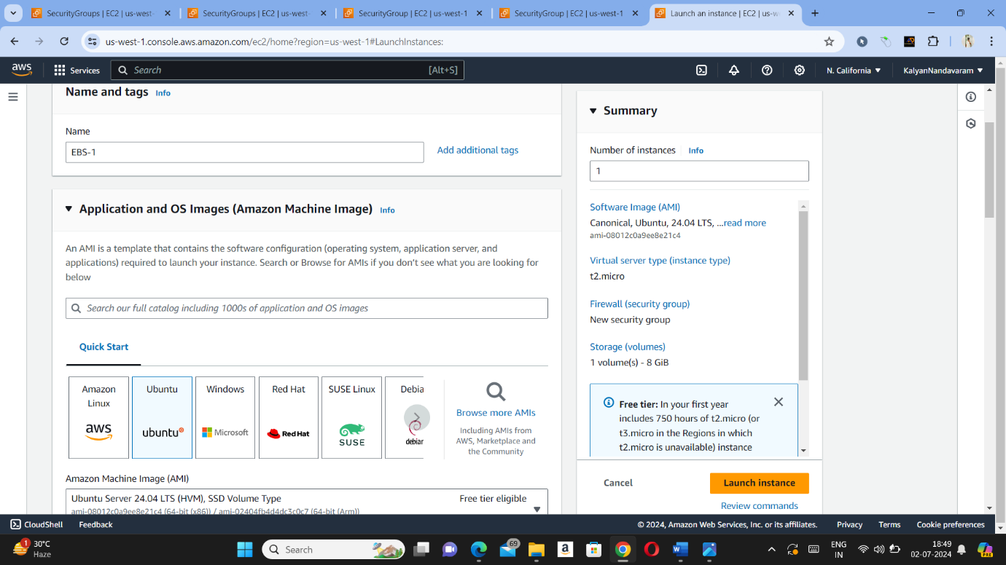

Step – 4 : Now we need to create a key pair and check configure storage and need to launch instance.

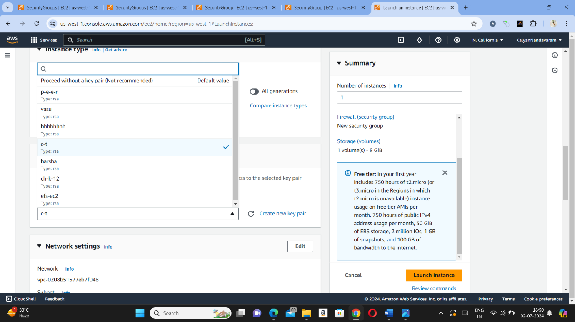

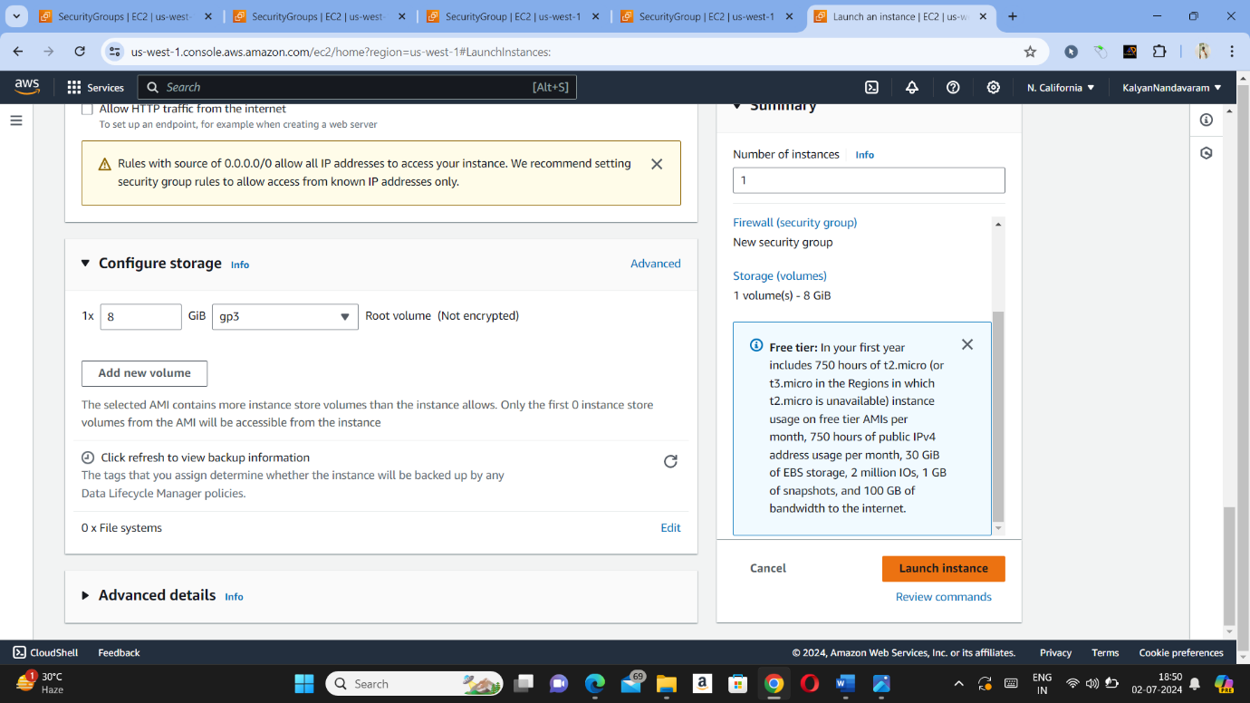

Step – 5 : Now we need to come EC2 dashboard and need to press on volume and check whether volume is created or not.

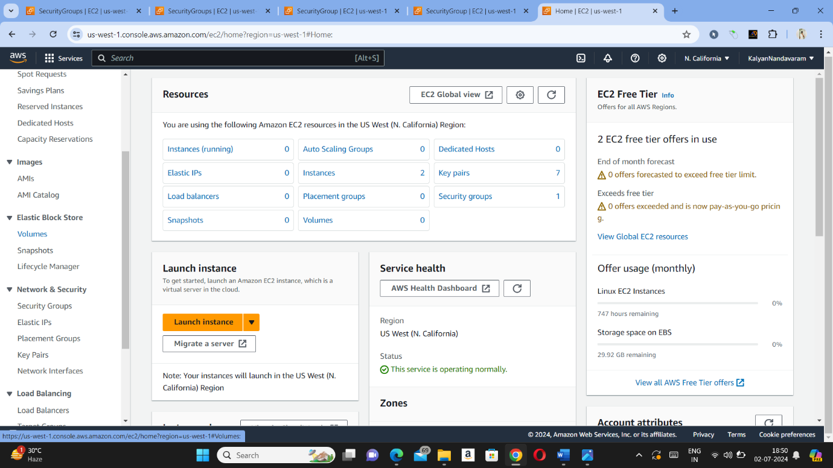

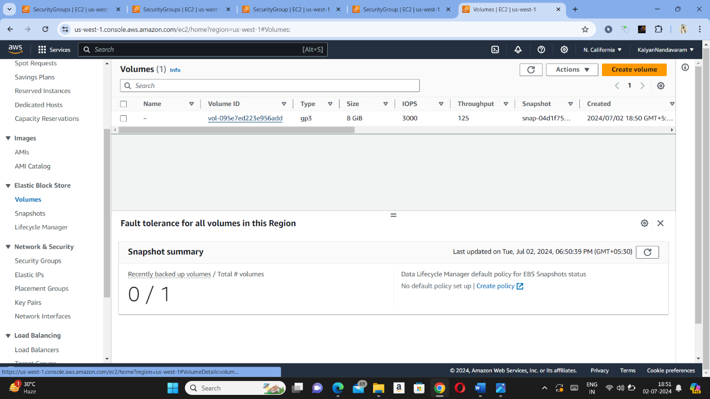

Step – 6 : Now we need to open instance which we have created in step – 2 and need to press connect and need to copy SSH link.

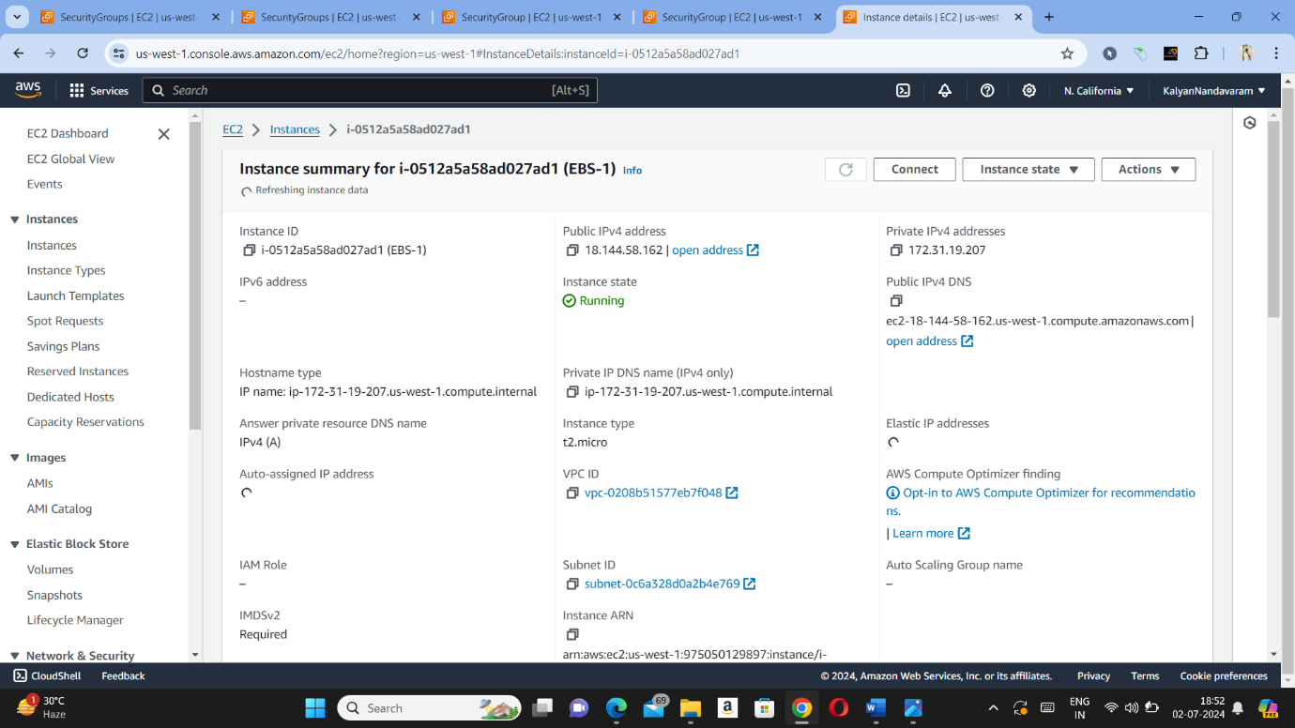

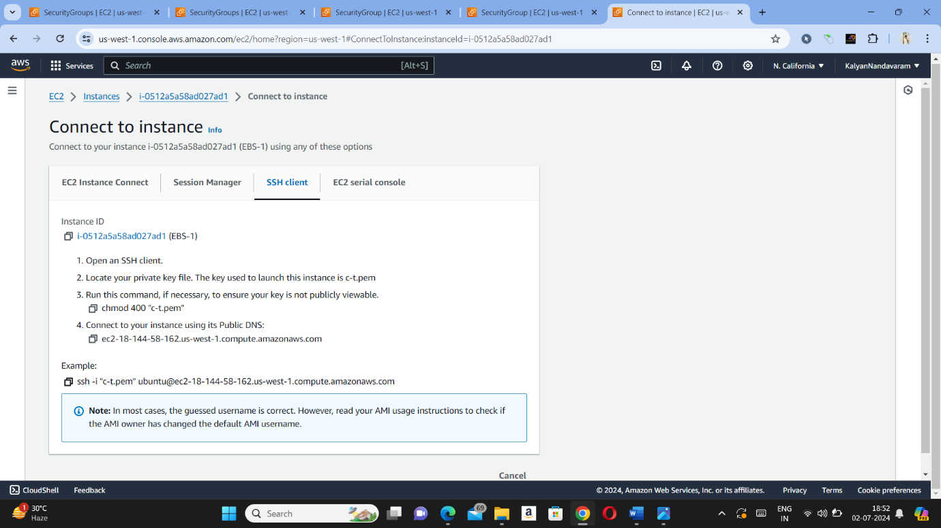

Step – 7 : Now we need to open Git bash and need to paste SSH link and press enter and need to press sudo -i to become root user.

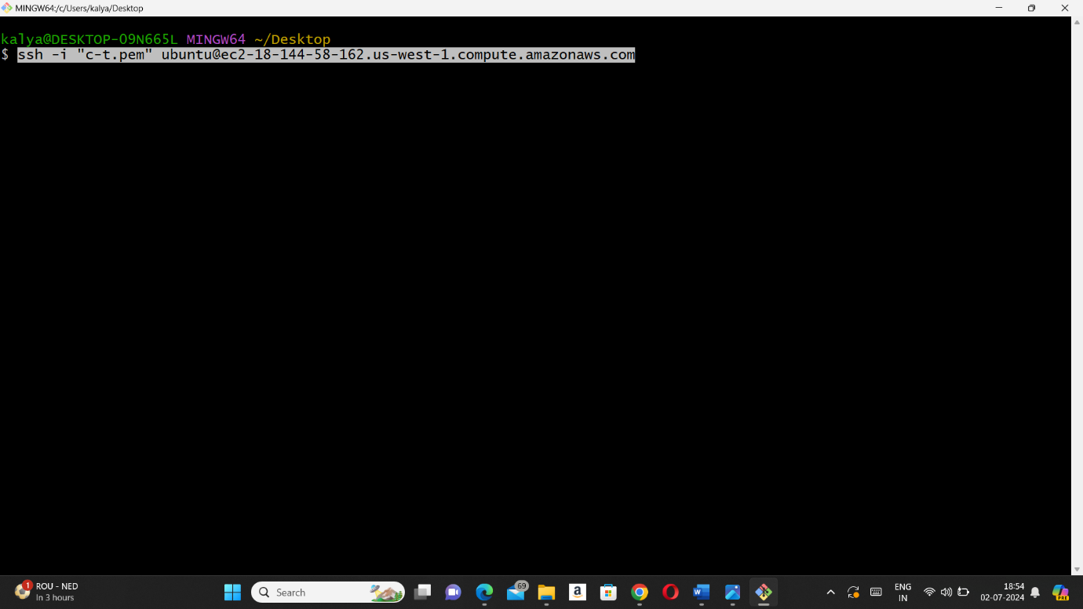

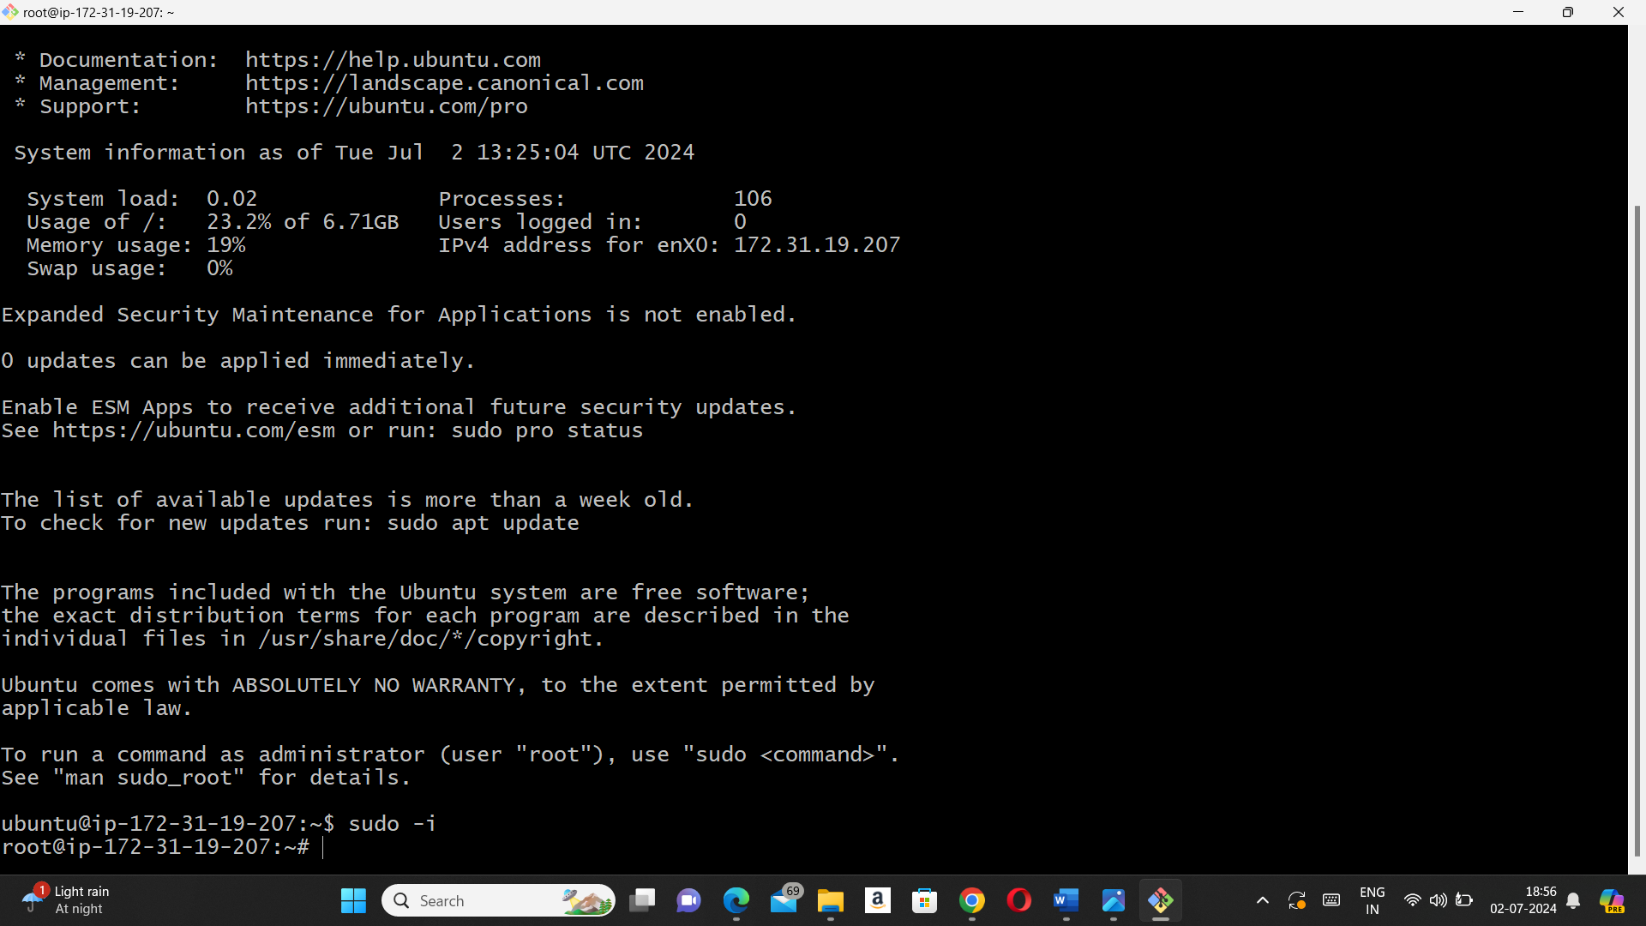

Step – 8 : Now we need to enter a command as df -h ( to view disk storage in human readable language).

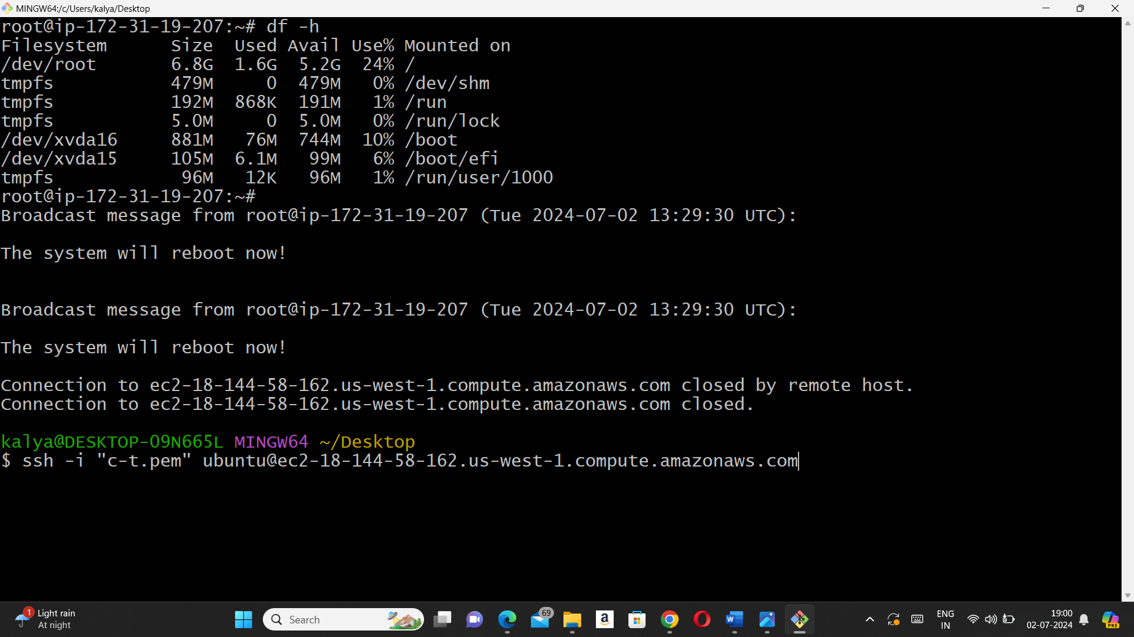

Step – 9 : Now we need to come back to volume in EC2 and we need to press modify volume in actions.

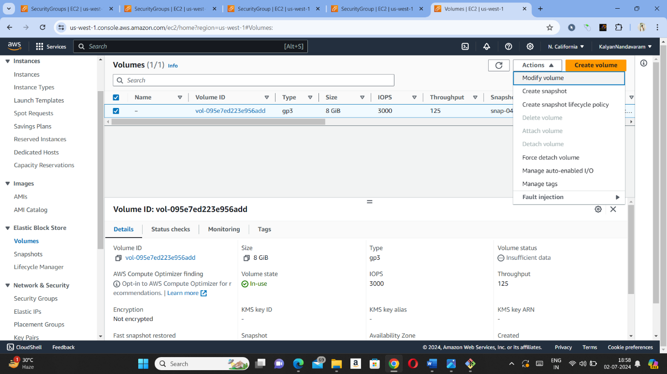

Step – 10 : After pressing modify volume, now we need to change size(GiB) and need to press modify.

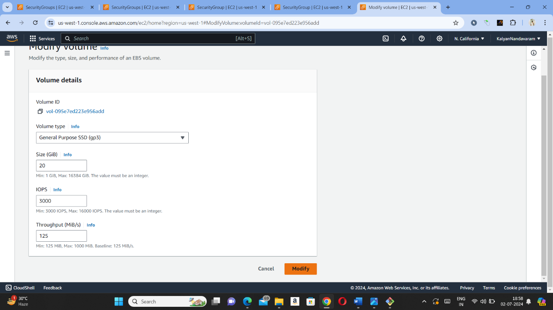

Step – 11 : Storage will not be updated when we check in disk storage(df -h) unless if we reboot it. So now we need to open instances and in instance state we need to reboot the instance.

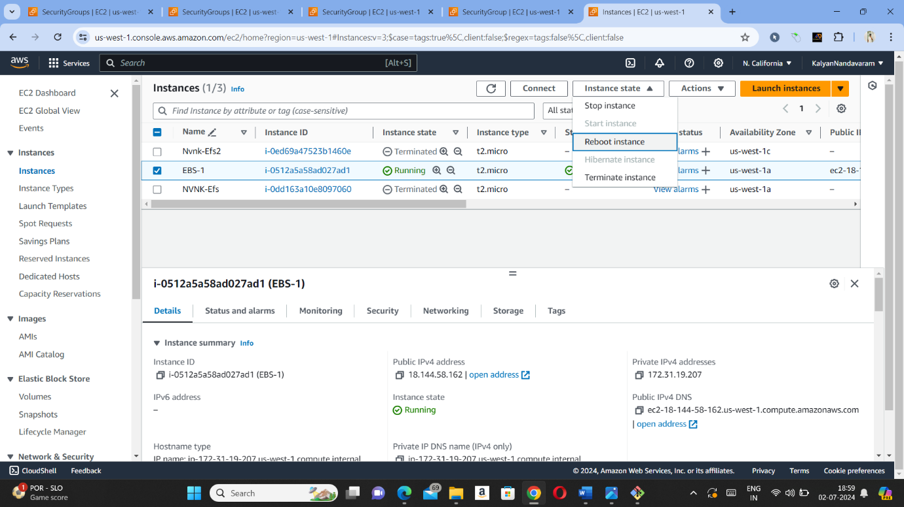

Step – 12 : Now we need to paste SSH link again in Gitbash and need to enter command (sudo -i) to become root user and need to enter command (df -h) to view disk storage and now storage will be modified.

